**CIS 229 – Python Programming – Programming Assignment**

**Vector Analysis**

Overview

In this assignment, the student will write a Python script that calculates the sum, difference, and magnitudes of two user defined vectors.

When completing this assignment, the student should demonstrate mastery of the following concepts:

* Basic User Prompting
* Variable Types and “Weak Typing”
* Mathematical Assignments
* Simple Output Formatting
* Intuitive Design

Assignment

Write a program that prompts the user for his/her name. After that, prompt the user for the x and y coordinates that will be assigned to two vectors.   
Have the program calculate the magnitude of the vectors and display the sum and difference of the vectors along with the user’s name. Make use of the input() and eval() appropriately when prompting the user. When displaying the result, round each value to three decimal positions. Make your output match the provided output as closely as possible.

The following mathematical definitions will be helpful in performing your calculations:

*Relating Square Roots to Exponents*

sqrt(x) = x(1/2)

*Pythagorean Theorem (for calculating magnitudes)*

A2 + b2 = c2

*Vector Addition*

<x1, y1> + <x2, y2> = <x1 + x2, y1 + y2>

*Vector Subtraction*

<x1, y1> - <x2, y2> = <x1 – x2, y1 – y2>

Example Screen Shot #1

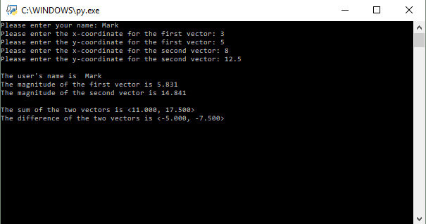

Assessment

This assignment will be assessed based on the provided grading rubric.